Nithin S
221IT085

IT250 Lab Assignment

Q1 ) Lex Program to count the number of words in a given sentence.

CODE
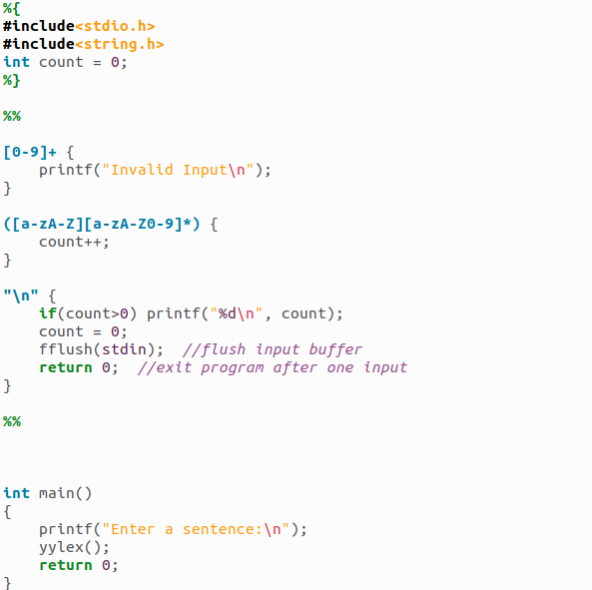
OUTPUT

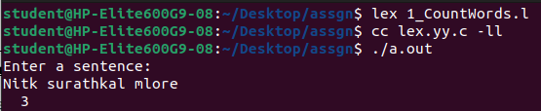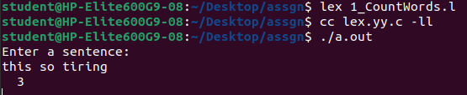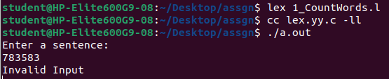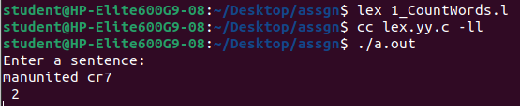

Q2) Lex program to check whether given number is prime number or not

CODE
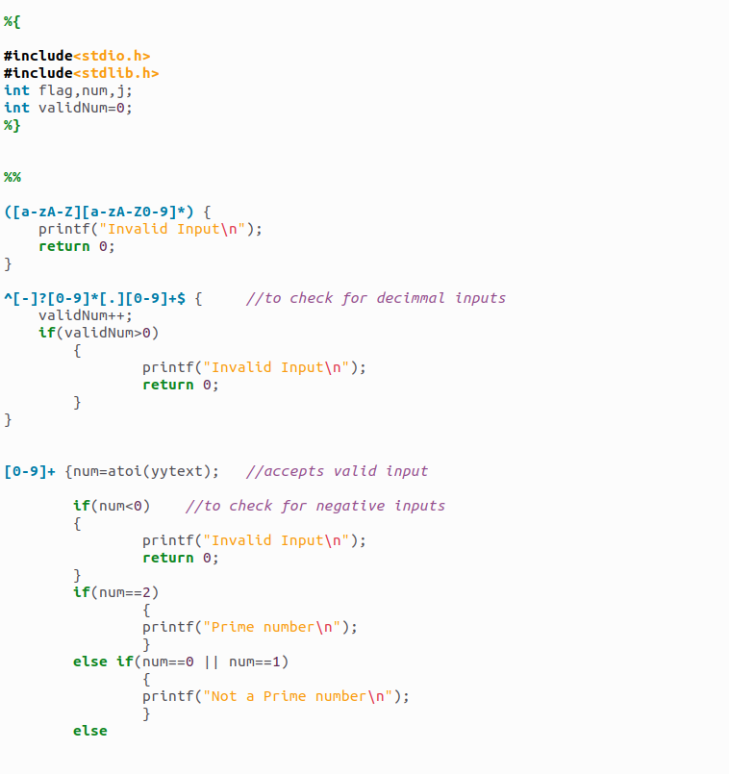

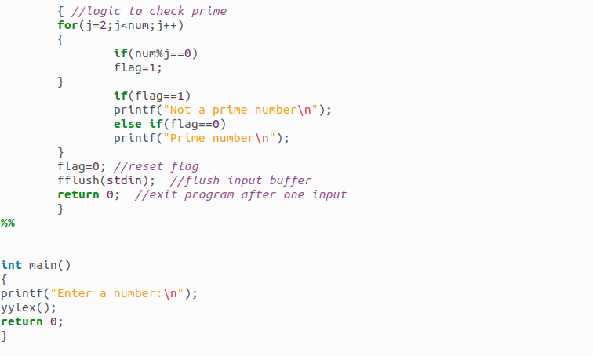

OUTPUT
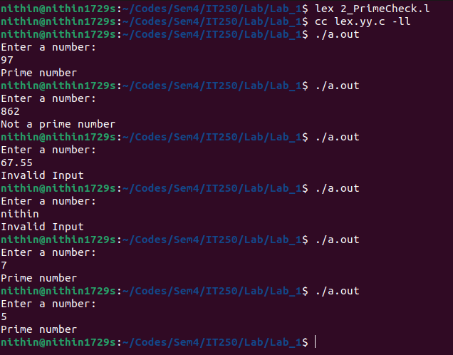

Q3) Lex program to check whether given number is armstrong number or not

CODE
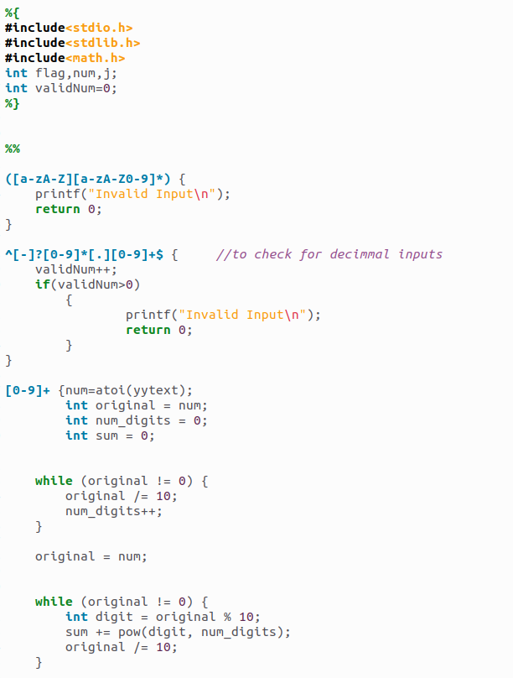
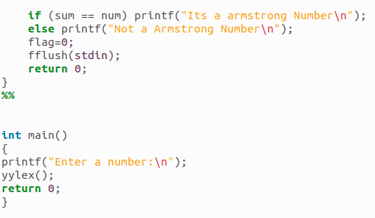

OUTPUT

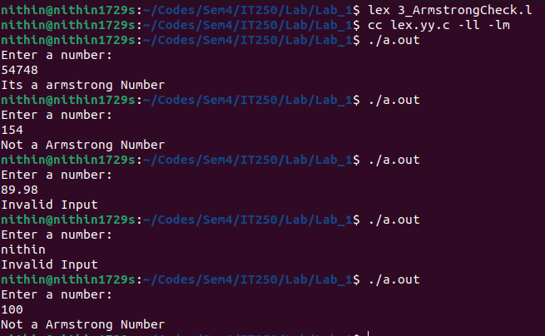

PS: Use -lm as a flag to use math.h header file

